Lab Report No 4

Understanding and implementing KNN algorithm for classification problem
Artificial Intelligence


Submitted By:
[Huzaifa Shahbaz]
[21-CE-009]
[Aqsa Shah]
[21-CE-039]
Submitted to:
Engr. Hareem Khan
Dated:
18thMar,2025

Department of Computer Engineering,
HITEC University, Taxila
Lab Example No 1:

Solution:
Brief description (3-5 lines)
IRIS DATASETS:
A classification problem solved by using KNN and implemented for IRIS dataset.
The code
import numpy as np
import matplotlib.pyplot as plt
from matplotlib.colors import ListedColormap
from scipy.stats import mode
from sklearn.metrics import accuracy_score, confusion_matrix
from sklearn.datasets import load_iris
from numpy.random import randint
# Function Definitions
# Euclidean Distance Function
def euclidean(p1, p2):
return np.sqrt(np.sum((p1 - p2) ** 2))
# KNN Prediction Function
def predict(x_train, y_train, x_input, k):
op_labels = []
for item in x_input:
point_dist = [(euclidean(x_train[j], item), y_train[j]) for j in range(len(x_train))]
point_dist.sort(key=lambda x: x[0]) # Sort by distance
k_nearest_labels = [label for _, label in point_dist[:k]]
most_common = mode(k_nearest_labels, keepdims=True) # Majority voting
op_labels.append(most_common.mode[0])
return np.array(op_labels)
# Load Dataset
iris = load_iris()
X = iris.data
y = iris.target
feature_names = iris.feature_names
target_names = iris.target_names
# Train-Test Split
np.random.seed(42) # For reproducibility
train_indices = randint(0, 150, 100)
test_indices = np.array([i for i in range(150) if i not in train_indices])[:50]
X_train, y_train = X[train_indices], y[train_indices]
X_test, y_test = X[test_indices], y[test_indices]
# Apply KNN
k = 7 # Number of neighbors
y_pred = predict(X_train, y_train, X_test, k)
# Compute Accuracy
accuracy = accuracy_score(y_test, y_pred)
print(f"Accuracy: {accuracy:.4f}")
# Confusion Matrix
cm = confusion_matrix(y_test, y_pred)
print("Confusion Matrix:")
print(cm)
# Data Visualization
# Select only two features for visualization (Sepal Length & Sepal Width)
feature_idx = [0, 1]
X_train_2d, X_test_2d = X_train[:, feature_idx], X_test[:, feature_idx]
# Create Mesh Grid for Decision Boundary
h = 0.02 # Step size
x_min, x_max = X[:, feature_idx[0]].min() - 1, X[:, feature_idx[0]].max() + 1
y_min, y_max = X[:, feature_idx[1]].min() - 1, X[:, feature_idx[1]].max() + 1
xx, yy = np.meshgrid(np.arange(x_min, x_max, h), np.arange(y_min, y_max, h))
# Predict for Each Grid Point
Z = predict(X_train_2d, y_train, np.c_[xx.ravel(), yy.ravel()], k)
Z = Z.reshape(xx.shape)
# Define Color Maps
cmap_light = ListedColormap(['#FFAAAA', '#AAFFAA', '#AAAAFF'])
cmap_bold = ListedColormap(['#FF0000', '#00FF00', '#0000FF'])
# Plot Figures
plt.figure(figsize=(12, 10))
# 1. KNN Decision Boundary
plt.subplot(2, 2, 1)
plt.contourf(xx, yy, Z, alpha=0.4, cmap=cmap_light)
plt.scatter(X_train_2d[:, 0], X_train_2d[:, 1], c=y_train, cmap=cmap_bold, edgecolor='k', s=40)
plt.scatter(X_test_2d[:, 0], X_test_2d[:, 1], c=y_test, cmap=cmap_bold, marker='*', s=100, edgecolor='k')
plt.xlabel(feature_names[feature_idx[0]])
plt.ylabel(feature_names[feature_idx[1]])
plt.title(f'KNN Decision Boundary (k={k})')
plt.legend(['Training data', 'Test data'])
# 2. Iris Dataset Distribution (Sepal Length vs Sepal Width)
plt.subplot(2, 2, 2)
for i, color in zip(range(3), ['red', 'green', 'blue']):
plt.scatter(X[y == i, 0], X[y == i, 1], color=color, alpha=0.7, label=target_names[i])
plt.xlabel(feature_names[0])
plt.ylabel(feature_names[1])
plt.title('Iris Dataset: Sepal Length vs Sepal Width')
plt.legend()
# 3. Correct vs Incorrect Predictions
plt.subplot(2, 2, 3)
correct = y_pred == y_test
plt.scatter(X_test_2d[correct, 0], X_test_2d[correct, 1], c=y_test[correct], cmap=cmap_bold, marker='o', s=80, edgecolor='k', label='Correct')
plt.scatter(X_test_2d[~correct, 0], X_test_2d[~correct, 1], c=y_test[~correct], cmap=cmap_bold, marker='x', s=100, edgecolor='k', label='Incorrect')
plt.xlabel(feature_names[feature_idx[0]])
plt.ylabel(feature_names[feature_idx[1]])
plt.title(f'KNN Predictions: Correct vs Incorrect (k={k})')
plt.legend()
# 4. Accuracy vs k values
plt.subplot(2, 2, 4)
k_values = range(1, 15, 2)
accuracy_values = [accuracy_score(y_test, predict(X_train, y_train, X_test, k_val)) for k_val in k_values]
plt.plot(k_values, accuracy_values, 'o-', color='blue')
plt.axvline(x=k, color='red', linestyle='--', label=f'k={k}')
plt.xlabel('k value')
plt.ylabel('Accuracy')
plt.title('Accuracy vs k value')
plt.grid(True)
plt.legend()
plt.tight_layout()
plt.show()
# Print Accuracy for Different k Values
print("\nAccuracy for different k values:")
for k_val, acc in zip(k_values, accuracy_values):
print(f"k = {k_val}: {acc:.4f}")
The results (Screenshot)
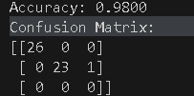
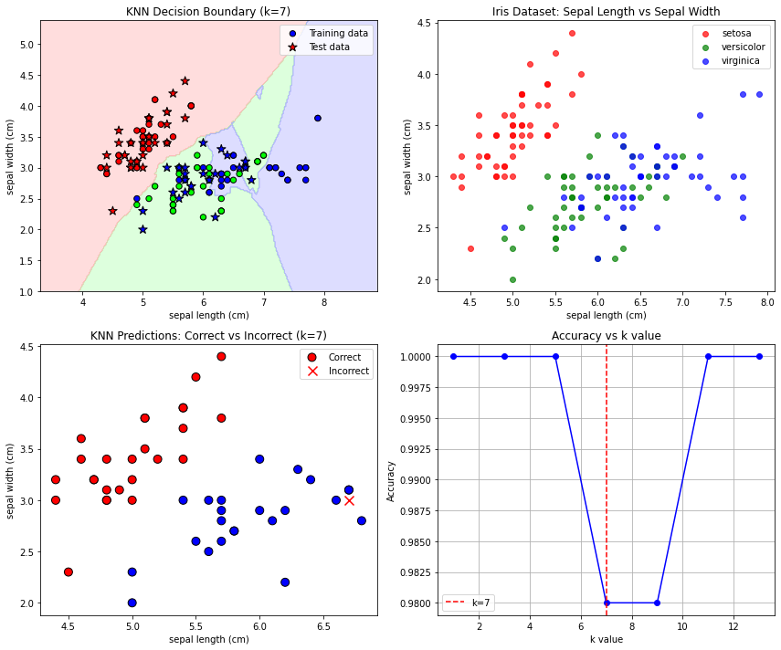
Lab Task No 1:

Solution:
Brief description (3-5 lines)
Write the above-mentioned program for different datasets. Show data head with features used and corresponding labels in case of classification problem. Evaluate results for all metrics.
The code
import numpy as np
import pandas as pd
import matplotlib.pyplot as plt
from sklearn.datasets import load_iris, load_wine, load_breast_cancer, fetch_california_housing
from sklearn.model_selection import train_test_split
from sklearn.preprocessing import StandardScaler
from sklearn.linear_model import LogisticRegression
from sklearn.ensemble import RandomForestClassifier
from sklearn.metrics import accuracy_score, precision_score, recall_score, f1_score, roc_auc_score, confusion_matrix
from sklearn.metrics import classification_report
# Set random seed for reproducibility
np.random.seed(42)
# Function to load and preprocess classification datasets
def load_classification_dataset(dataset_name):
if dataset_name == 'iris':
data = load_iris()
X = pd.DataFrame(data.data, columns=data.feature_names)
y = pd.Series(data.target, name='target')
class_names = data.target_names
elif dataset_name == 'wine':
data = load_wine()
X = pd.DataFrame(data.data, columns=data.feature_names)
y = pd.Series(data.target, name='target')
class_names = data.target_names
elif dataset_name == 'breast_cancer':
data = load_breast_cancer()
X = pd.DataFrame(data.data, columns=data.feature_names)
y = pd.Series(data.target, name='target')
class_names = data.target_names
return X, y, class_names
# Function to evaluate classifiers and collect metrics
def evaluate_classifier(X, y, class_names, dataset_name):
# Split data
X_train, X_test, y_train, y_test = train_test_split(X, y, test_size=0.3, random_state=42)
# Standardize features
scaler = StandardScaler()
X_train_scaled = scaler.fit_transform(X_train)
X_test_scaled = scaler.transform(X_test)
# Initialize models
models = {
'Logistic Regression': LogisticRegression(max_iter=1000, random_state=42),
'Random Forest': RandomForestClassifier(n_estimators=100, random_state=42)
}
results = {}
# Train and evaluate each model
for name, model in models.items():
model.fit(X_train_scaled, y_train)
y_pred = model.predict(X_test_scaled)
# For multi-class, use 'macro' averaging
avg_method = 'macro' if len(class_names) > 2 else 'binary'
# Calculate metrics
metrics = {
'accuracy': accuracy_score(y_test, y_pred),
'precision': precision_score(y_test, y_pred, average=avg_method),
'recall': recall_score(y_test, y_pred, average=avg_method),
'f1': f1_score(y_test, y_pred, average=avg_method)
}
# Add ROC AUC for binary classification
if len(class_names) == 2:
y_prob = model.predict_proba(X_test_scaled)[:, 1]
metrics['roc_auc'] = roc_auc_score(y_test, y_prob)
# Add confusion matrix
metrics['confusion_matrix'] = confusion_matrix(y_test, y_pred)
# Add classification report
metrics['classification_report'] = classification_report(y_test, y_pred, target_names=class_names)
results[name] = metrics
return results
# Main execution
def main():
# List of datasets to analyze
datasets = ['iris', 'wine', 'breast_cancer']
all_results = {}
# Process each dataset
for dataset_name in datasets:
print(f"\n{'='*50}")
print(f"Dataset: {dataset_name.upper()}")
print(f"{'='*50}")
# Load and prepare data
X, y, class_names = load_classification_dataset(dataset_name)
# Display data info
print(f"\nData shape: {X.shape}")
print(f"Number of classes: {len(class_names)}")
print(f"Class names: {class_names}")
print(f"Class distribution: {np.bincount(y)}")
# Display data head
print("\nFeatures (first 5 rows):")
print(X.head())
print("\nLabels (first 5 values):")
print(y.head())
# Train and evaluate models
results = evaluate_classifier(X, y, class_names, dataset_name)
all_results[dataset_name] = results
# Print results
for model_name, metrics in results.items():
print(f"\nModel: {model_name}")
print(f"Accuracy: {metrics['accuracy']:.4f}")
print(f"Precision: {metrics['precision']:.4f}")
print(f"Recall: {metrics['recall']:.4f}")
print(f"F1 Score: {metrics['f1']:.4f}")
if 'roc_auc' in metrics:
print(f"ROC AUC: {metrics['roc_auc']:.4f}")
print("\nConfusion Matrix:")
print(metrics['confusion_matrix'])
print("\nClassification Report:")
print(metrics['classification_report'])
# Visualize results
plot_comparison(all_results)
# Function to create comparison plots
def plot_comparison(all_results):
metrics_to_plot = ['accuracy', 'precision', 'recall', 'f1']
datasets = list(all_results.keys())
models = list(all_results[datasets[0]].keys())
# Create a figure with subplots
fig, axes = plt.subplots(len(metrics_to_plot), 1, figsize=(12, 16))
# Set spacing between subplots
plt.subplots_adjust(hspace=0.4)
# Plot each metric
for i, metric in enumerate(metrics_to_plot):
ax = axes[i]
# Prepare data for plotting
x = np.arange(len(datasets))
width = 0.35
# Plot bars for each model
for j, model in enumerate(models):
values = [all_results[dataset][model][metric] for dataset in datasets]
ax.bar(x + j*width, values, width, label=model)
# Customize the plot
ax.set_title(f'{metric.capitalize()} Comparison')
ax.set_xlabel('Dataset')
ax.set_ylabel(metric.capitalize())
ax.set_xticks(x + width/2)
ax.set_xticklabels(datasets)
ax.legend()
# Add values on top of bars
for j, model in enumerate(models):
values = [all_results[dataset][model][metric] for dataset in datasets]
for k, v in enumerate(values):
ax.text(x[k] + j*width, v + 0.01, f'{v:.3f}', ha='center', va='bottom', fontsize=8)
plt.suptitle('Performance Metrics Comparison Across Datasets', fontsize=16)
plt.tight_layout(rect=[0, 0, 1, 0.97])
plt.show()
# Run the program
if __name__ == "__main__":
main()
The results (Screenshot)
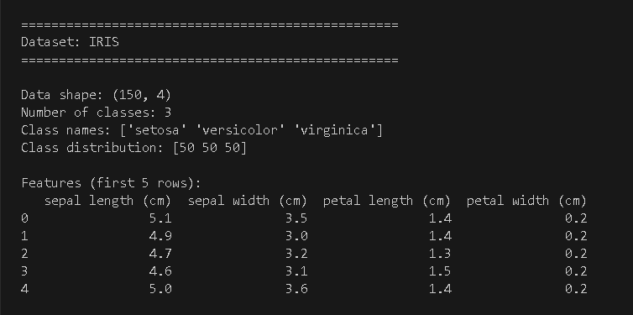
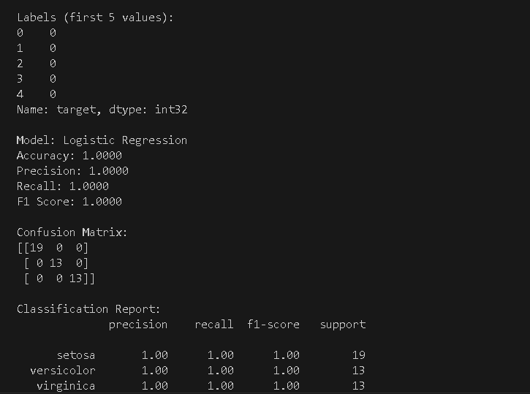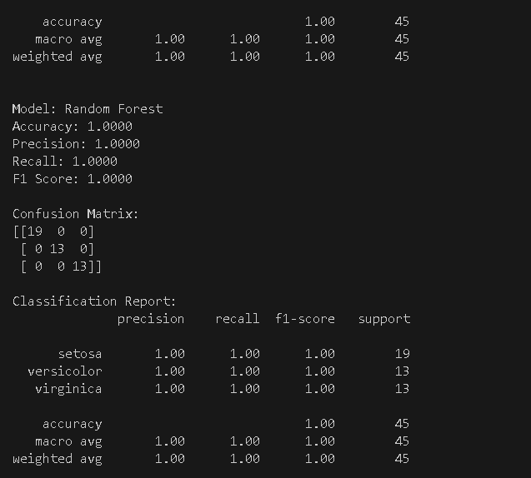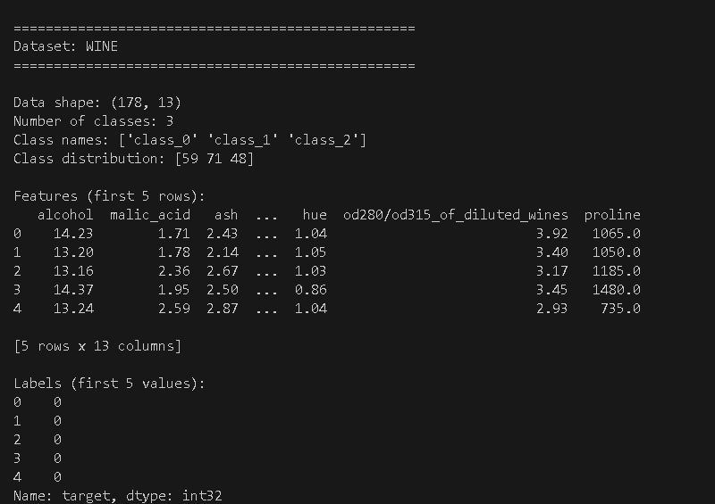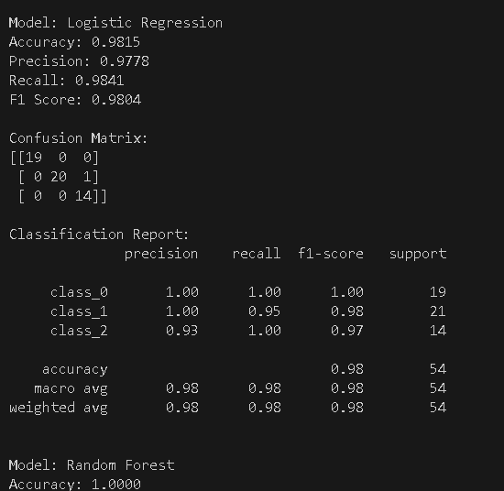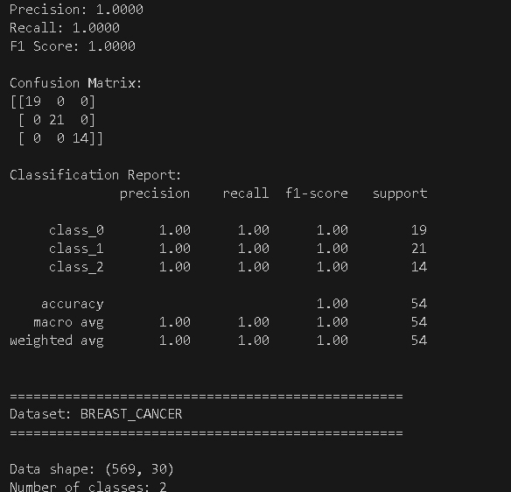
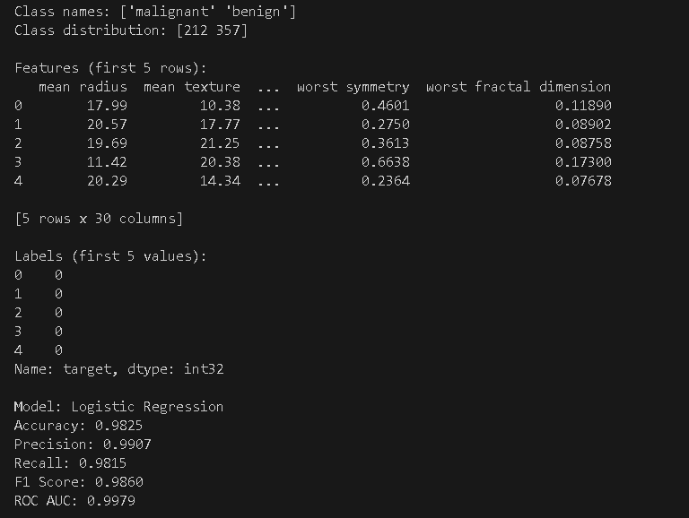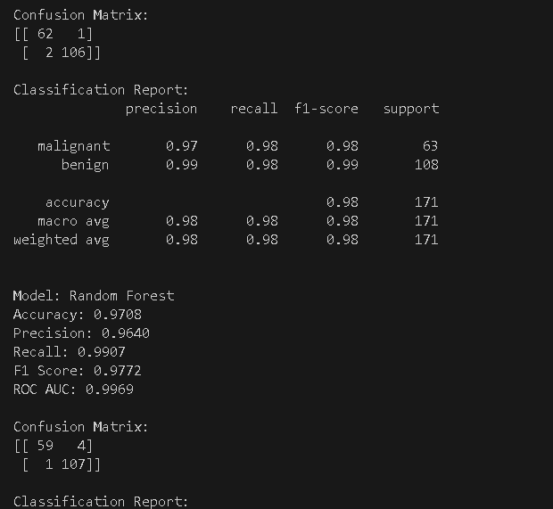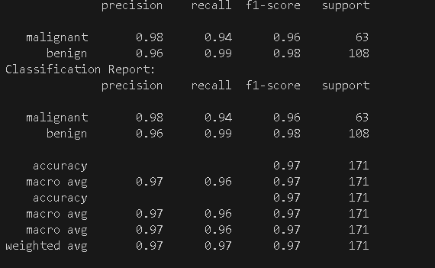
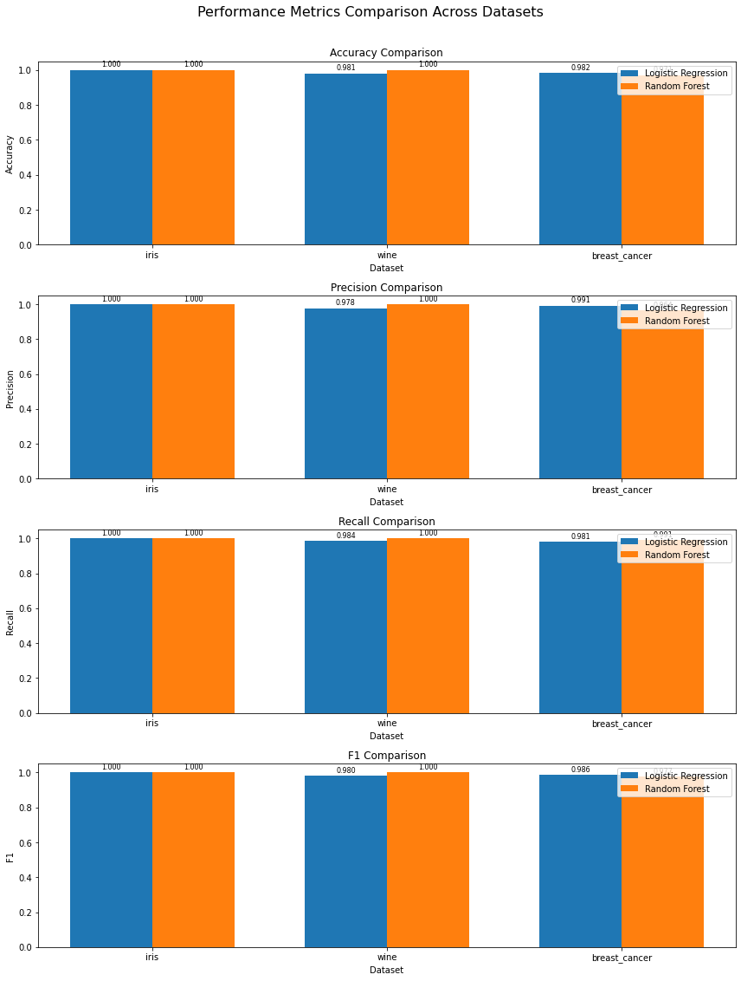
Lab Task No 2:

Solution:
Brief description (3-5 lines)
Use KNN for regression dataset. Show data head with features used and corresponding labels in case of classification problem. Evaluate results for all metrics.
The code
import numpy as np
import pandas as pd
import matplotlib.pyplot as plt
from sklearn.datasets import fetch_california_housing
from sklearn.model_selection import train_test_split
from sklearn.neighbors import KNeighborsRegressor
from sklearn.preprocessing import StandardScaler
from sklearn.metrics import mean_squared_error, mean_absolute_error, r2_score
from sklearn.model_selection import GridSearchCV
# Load the California housing dataset as an example regression dataset
housing = fetch_california_housing()
X = pd.DataFrame(housing.data, columns=housing.feature_names)
y = housing.target
# Display information about the dataset
print("Dataset Information:")
print(f"Number of samples: {X.shape[0]}")
print(f"Number of features: {X.shape[1]}")
print("\nFeature names:")
print(housing.feature_names)
print("\nTarget description:")
print(housing.DESCR.split('\n')[4]) # Extract target description from dataset description
# Show the first 5 rows of the dataset with features and target
data_with_target = X.copy()
data_with_target['Target (MedHouseValue)'] = y
print("\nFirst 5 rows of the dataset:")
print(data_with_target.head())
# Split the data into training and testing sets
X_train, X_test, y_train, y_test = train_test_split(X, y, test_size=0.2, random_state=42)
# Scale the features
scaler = StandardScaler()
X_train_scaled = scaler.fit_transform(X_train)
X_test_scaled = scaler.transform(X_test)
# Find the optimal value of K using GridSearchCV
param_grid = {'n_neighbors': np.arange(3, 21, 2)}
knn_grid = GridSearchCV(KNeighborsRegressor(), param_grid, cv=5, scoring='neg_mean_squared_error')
knn_grid.fit(X_train_scaled, y_train)
# Print the best parameter
best_k = knn_grid.best_params_['n_neighbors']
print(f"\nBest value of K: {best_k}")
# Train KNN regression model with the best K
knn_model = KNeighborsRegressor(n_neighbors=best_k)
knn_model.fit(X_train_scaled, y_train)
# Make predictions
y_pred = knn_model.predict(X_test_scaled)
# Evaluate the model using various metrics
mse = mean_squared_error(y_test, y_pred)
rmse = np.sqrt(mse)
mae = mean_absolute_error(y_test, y_pred)
r2 = r2_score(y_test, y_pred)
print("\nModel Evaluation Metrics:")
print(f"Mean Squared Error (MSE): {mse:.4f}")
print(f"Root Mean Squared Error (RMSE): {rmse:.4f}")
print(f"Mean Absolute Error (MAE): {mae:.4f}")
print(f"R-squared (R²): {r2:.4f}")
# Calculate additional metrics
explained_variance = 1 - (np.var(y_test - y_pred) / np.var(y_test))
mape = np.mean(np.abs((y_test - y_pred) / y_test)) * 100
print(f"Explained Variance: {explained_variance:.4f}")
print(f"Mean Absolute Percentage Error (MAPE): {mape:.4f}%")
# Visualize actual vs predicted values
plt.figure(figsize=(10, 6))
plt.scatter(y_test, y_pred, alpha=0.5)
plt.plot([y_test.min(), y_test.max()], [y_test.min(), y_test.max()], 'r--')
plt.xlabel('Actual Values')
plt.ylabel('Predicted Values')
plt.title('KNN Regression: Actual vs Predicted Values')
plt.tight_layout()
plt.show()
# Visualize error distribution
errors = y_test - y_pred
plt.figure(figsize=(10, 6))
plt.hist(errors, bins=30)
plt.xlabel('Prediction Error')
plt.ylabel('Count')
plt.title('Distribution of Prediction Errors')
plt.axvline(x=0, color='r', linestyle='--')
plt.tight_layout()
plt.show()
# Visualize the effect of K on model performance
k_range = range(1, 31)
k_mse = []
k_r2 = []
for k in k_range:
knn = KNeighborsRegressor(n_neighbors=k)
knn.fit(X_train_scaled, y_train)
y_pred_k = knn.predict(X_test_scaled)
k_mse.append(mean_squared_error(y_test, y_pred_k))
k_r2.append(r2_score(y_test, y_pred_k))
plt.figure(figsize=(12, 5))
plt.subplot(1, 2, 1)
plt.plot(k_range, k_mse)
plt.xlabel('Value of K')
plt.ylabel('MSE')
plt.title('MSE vs. K Value')
plt.subplot(1, 2, 2)
plt.plot(k_range, k_r2)
plt.xlabel('Value of K')
plt.ylabel('R²')
plt.title('R² vs. K Value')
plt.tight_layout()
plt.show()
The results (Screenshot)
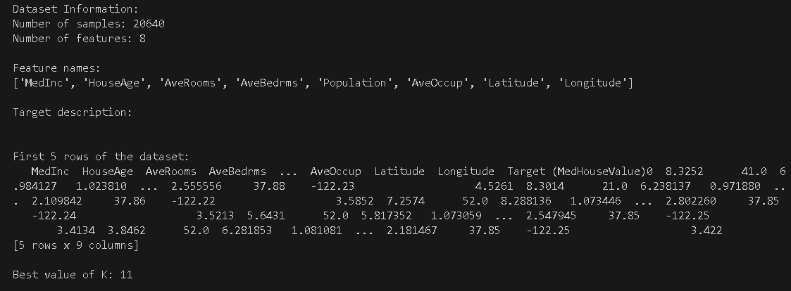
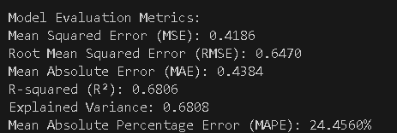
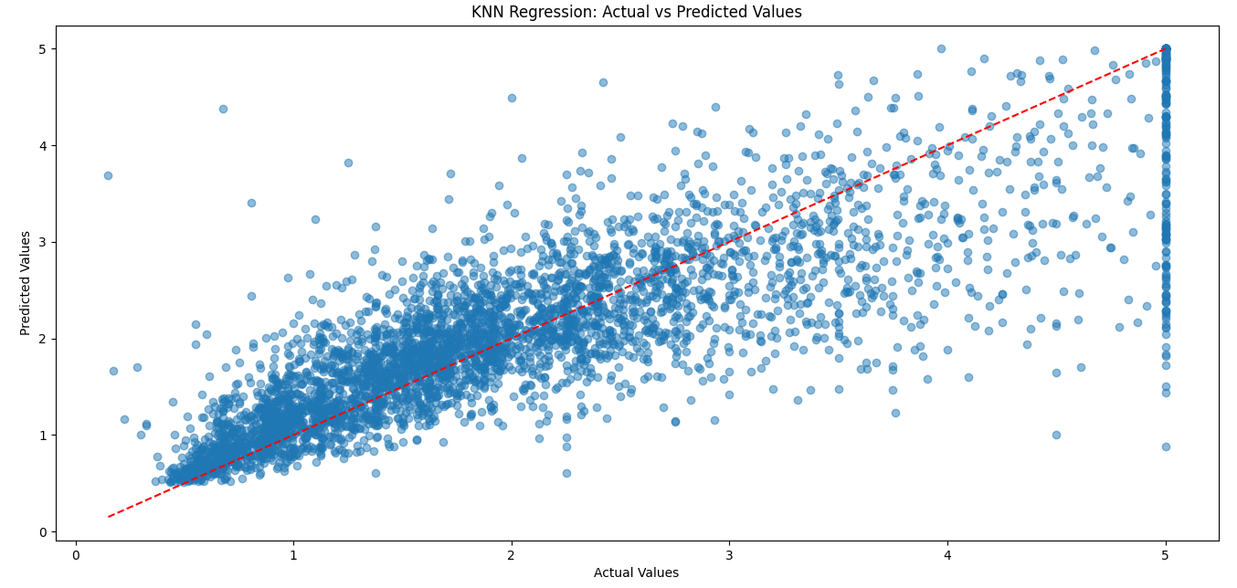

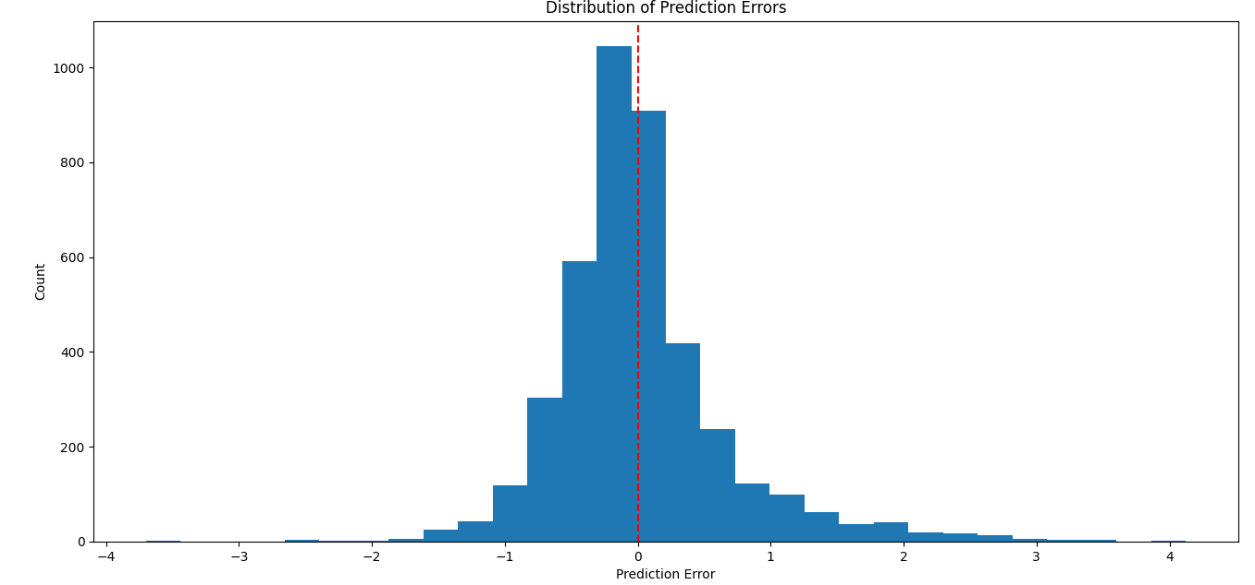
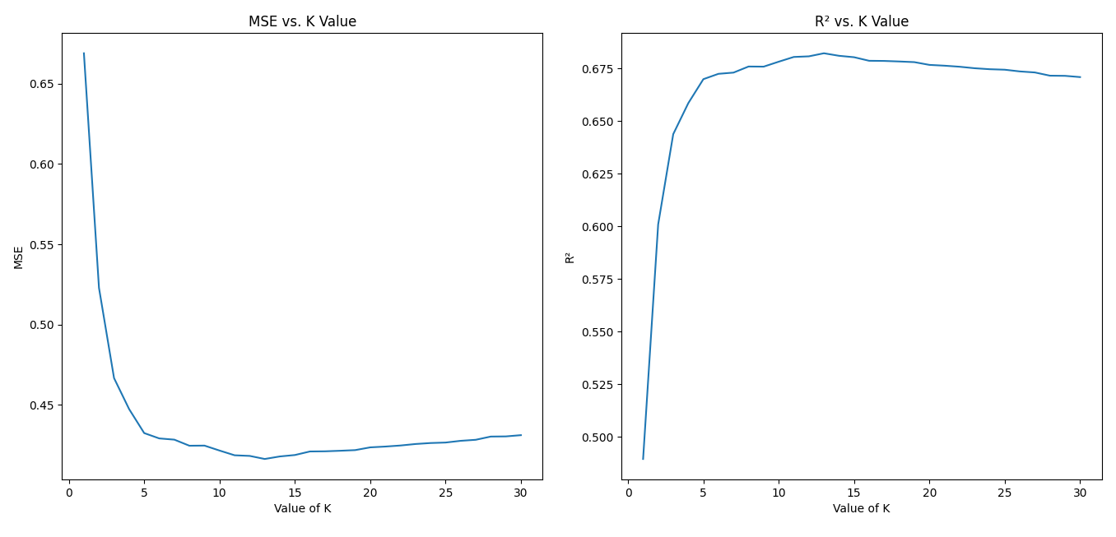
Conclusion
In conclusion, KNN classifies items according to the classification of the majority among K nearest neighbors within the feature space; for all this simplicity, KNN has indeed proved itself to be powerful for many classification tasks, without an explicit training phase. Key considerations would revolve around choosing the right K value, distance metric, and handling curse of dimensionality; the implementation would include only computing distances between points, sorting neighbors, and taking a vote of the nearest K samples; although it is computationally intensive when predicting, KNN still serves a valuable purpose in smaller datasets and as a baseline classifier to compare against more complex models.

